# Genset Perkins

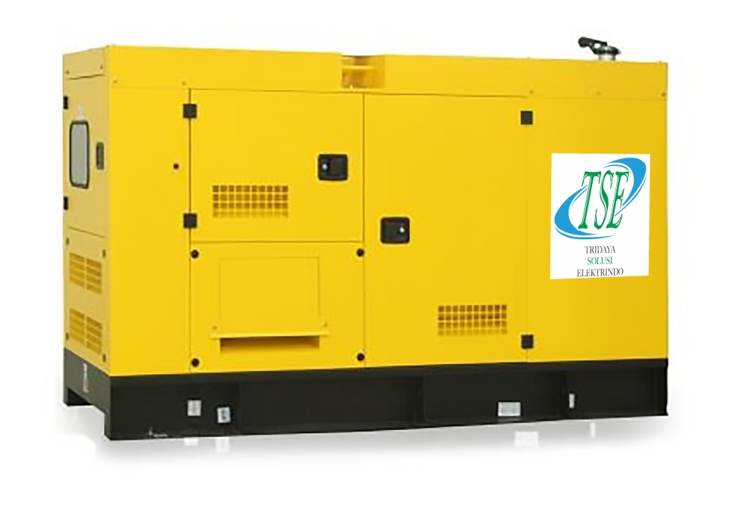

Austin Power adalah salah satu brand distributor Genset Perkins di Indonesia. Kami menjual genset Perkins dengan berbagai macam kapasitas dan spesifikasi lainnya secara lengkap.

Harga genset perkins type open dan silent type yang kami tawarkan sangat kompetitif dan bergaransi. Kamipun memiliki pelayanan purna jual (Afersales) untuk genset perkins, layanan service dengan kualitas terbaik yang didukung oleh teknisi yang handal dan bersertifikasi, serta ketersedian sparepart yang sangat lengkap.

Austin Power dengan mesin perkins menyediakan berbagai macam kapasitas terbaik untuk kebutuhan apapun, mulai dari kapasitas 9 kVA, 12,5 kVA, 20 kVA, 30 kVA, 45 kVA, 60 kVA, 80 kVA, 100 kVA, 135 kVA, 150 kVA, 180 kVA, 200 kVA, 250 kVA, 275 kVA, 300 kVA, 350 kVA, 400 kVA, 450 kVA, 500 kVA, 600 kVA, 650 kVA, 750 kVA, 800 kVA, 1000 kVA, 1250 kVA, 1500 kVA, 1700 kVA, 1850 kVA, 2000 kVA, 2250 kVA.

Untuk mengetahui ketersediaan produk anda dapat mengeceknya melalui katalog berikut yang berisikan informasi lengkap mengenai spesifikasi generator set dan harga yang tersedia.

|  |  |  |  |
| --- | --- | --- | --- |
| **Type Genset** | **kVA** | **Type Engine** | **Brochure** |
| TPP10T | 9 | 403A-G1 | [Download](https://drive.google.com/file/d/1uLX2Uliq6Iyjj-24nqFXIAnT7lAwIw25/view?usp=drive_link) |
| TPP15T | 13 | 403A-15G | [Download](https://drive.google.com/file/d/1ROUKpd9TpgaIk7VIZ9U2zn2izdl6qXb-/view?usp=sharing) |
| TPP15T | 13 | 403A - 15G1 | [Download](https://drive.google.com/file/d/1XAnklo7OSCAoxvpo4zLx95Np8i2gQ1UE/view?usp=sharing) |
| TPP22T | 20 | 404A - 22G1 | [Download](https://drive.google.com/file/d/1RW08jq_iPFD9WnkYqEzG1xI0aY2EPv_c/view?usp=sharing) |
| TPP22T | 20 | 404D - 22G | [Download](https://drive.google.com/file/d/1SrY7_rElLJbj1cb69d1mE0fZyephawo-/view?usp=sharing) |
| TPP33T | 30 | 1103A - 33G | [Download](https://drive.google.com/file/d/1qGfTpChf-UmUdGFznsH-XMYZLaJBPETL/view?usp=drive_link) |
| TPP50T | 45 | 1103A - 33TG1 | [Download](https://drive.google.com/file/d/1Yrq-rvA2naJy1HUSGH8ph1ag_b_zSAhf/view?usp=drive_link) |
| TPP66T | 60 | 1103A - 33TG2 | [Download](https://drive.google.com/file/d/1HzE9Zu9yj8KJAOdsonQC0h5U4n590q6f/view?usp=drive_link) |
| TPP88T | 80 | 1104A - 44TG2 | [Download](https://drive.google.com/file/d/1DpjsdPp1ELwmB_EXzB4mVEw2rmIvZ8mH/view?usp=drive_link) |
| TPP110T | 100 | 1104C - 44TAG2 | [Download](https://drive.google.com/file/d/16chi3cEXzOvteaeYDZZBzP7Exeh-PvMt/view?usp=drive_link) |
| TPP150T | 135 | 1106A - 70TG1 | [Download](https://drive.google.com/file/d/1xedSIWToZrXjLHANg9jDVonnN3a9RBdV/view?usp=drive_link) |
| TPP165T | 150 | 1106A - 70TAG2 | [Download](https://drive.google.com/file/d/1n71txCQ5ckT-1Ytb3nvLXjFSPn5Ou9Kj/view?usp=drive_link) |
| TPP200T | 180 | 1106A - 70TAG3 | [Download](https://drive.google.com/file/d/1sP7uJ7SyYwGAJjrNrS1yWqPs46KtChI1/view?usp=drive_link) |
| TPP220T | 200 | 1106A - 70TAG4 | [Download](https://drive.google.com/file/d/1o9afoPEWvtmzRaNem8V9gd0YBiUujMMZ/view?usp=drive_link) |
| TPP250T | 227 | 1506A - E88TAG2 | [Download](https://drive.google.com/file/d/15RWexgiKlL_Y3JxJ3R9PaxHNwg1OaJZa/view?usp=drive_link) |
| TPP275T | 250 | 1206A E70TTAG3 | [Download](https://drive.google.com/file/d/1HKOwpmLUqTNu-l1OKVjeOegiW1lMJgY4/view?usp=drive_link) |
| TPP300T | 275 | 1506A - E88TAG4 | [Download](https://drive.google.com/file/d/1g-kNjy6zHefGBRB3OGOfw4ILtZbxCMdr/view?usp=drive_link) |
| TPP330T | 300 | 1706A-E93TAG1 | [Download](https://drive.google.com/file/d/1u1jeAUybXXHFKIOKpGodwuisyyFjHavf/view?usp=drive_link) |
| TPP385T | 350 | 2206A - E13TAG2 | [Download](https://drive.google.com/file/d/1ywlAi_MrnrER18uoQBe6UEFWGZ0DZpBF/view?usp=drive_link) |
| TPP440T | 400 | 2206A - E13TAG3 | [Download](https://drive.google.com/file/d/121kPEU8duE4ORjZjJ13nj-M-cCN6q52v/view?usp=drive_link) |
| TPP500T | 450 | 2506A - E15TAG1 | [Download](https://drive.google.com/file/d/1-oJ14-ylATmyQz3qgc7Fs2nN7Iisl4Bb/view?usp=sharing) |
| TPP550T | 500 | 2506C - E15TAG2 | [Download](https://drive.google.com/file/d/1qI_v9e0qi_k6nUEbMzyK9-SIcDq5TVQe/view?usp=drive_link) |
| TPP660T | 600 | 2806C-E18TAG1A | [Download](https://drive.google.com/file/d/1VRRA0FRPKIr1wlqspc1uuxrHfLjSElB0/view?usp=drive_link) |
| TPP700T | 650 | 2806A - E18TAG2 | [Download](https://drive.google.com/file/d/14Gwp-jybMgiPVqA3cZrG-ZCpbVxgr5LM/view?usp=sharing) |
| TPP825T | 750 | 4006 - 23TAG2A | [Download](https://drive.google.com/file/d/1eMi-tRdoVmWu93xk6I9k9vzbTn6DazYd/view?usp=drive_link) |
| TPP880T | 800 | 4006 - 23TAG3A | [Download](https://drive.google.com/file/d/1MKdpNJ95XAwqYY9vV5B5aU3iPlM32wIV/view?usp=drive_link) |
| TPP1100T | 1000 | 4008TAG2A | [Download](https://drive.google.com/file/d/1SelH6eZk10c4tkkhGFus_50mWGL4ANMc/view?usp=drive_link) |
| TPP1375T | 1250 | 4012 - 46TWG2A | [Download](https://drive.google.com/file/d/10e659lz502wWsAh_F1ifAKYHsffoNJ-l/view?usp=drive_link) |
| TPP1650T | 1505 | 4012 - 46TAG2A | [Download](https://drive.google.com/file/d/1r6vtVzwz4XSCpMOu4vamSHC3s-EZOjN5/view?usp=drive_link) |
| TPP1875T | 1705 | 4012 - 46TAG3A | [Download](https://drive.google.com/file/d/1zeQL2FJErD0zUi-Pp-9CUhJBCk3akIZK/view?usp=drive_link) |
| TPP2000T | 1850 | 4016TAG1A | [Download](https://drive.google.com/file/d/1qI_v9e0qi_k6nUEbMzyK9-SIcDq5TVQe/view?usp=sharing) |
| TPP2250T | 2058 | 4016TAG2A | [Download](https://drive.google.com/file/d/1ov0fp5KA2SSV02K_dvT-IVPn4ImAU0Qc/view?usp=drive_link) |
| TPP2500T | 2250 | 4016 - 61TRG3 | [Download](https://drive.google.com/file/d/1WCBZpk_i1C8GUNtmMK7cKyU92PamokAd/view?usp=drive_link) |