# Genset TPC

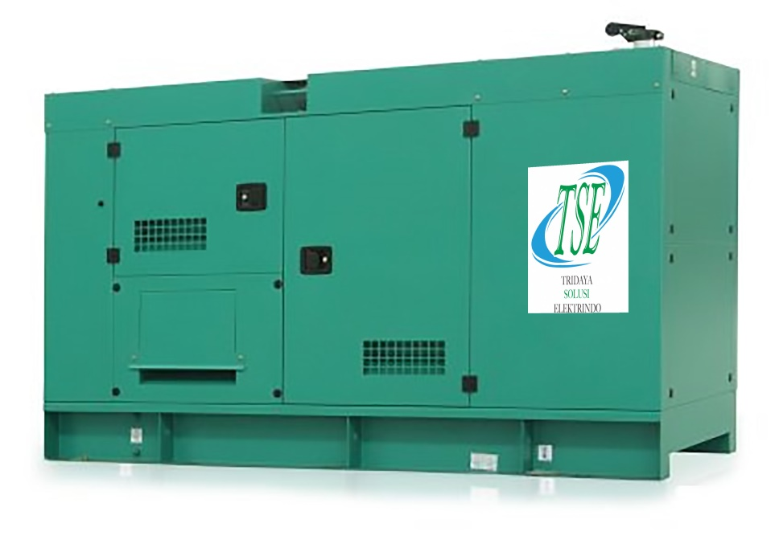

Austin Power adalah salah satu brand distributor Genset Austin Power di Indonesia. Kami menjual genset Austin dengan berbagai macam Kapasitas dan spesifikasi lainnya secara lengkap.

Harga genset Austin tipe Open dan Silent yang kami tawarkan sangat kompetitif dan bergaransi. Kamipun memiliki pelayanan purna jual (Aftersales) untuk genset APC powered by Cummins, layanan service dengan kualitas terbaik yang didukung oleh teknisi handal dan bersertifikat, serta ketersedian sparepart yang sangat lengkap.

Genset APC powered by Cummins menyediakan berbagai macam kapasitas terbaik untuk kebutuhan apapun, mulai dari kapasitas 27 kVA, 40 kVA, 50 kVA, 65 kVA, 72 kVA, 85 kVA,  100 kVA, 114 kVA, 135 kVA, 150 kVA, 160 kVA, 180 kVA, 200 kVA, 227 kVA, 250 kVA, 288 kVA, 313 kVA, 325 kVA, 344 kVA, 400 kVA, 450 kVA, 500 kVA, 568 kVA, 625 kVA, 650 kVA, 750 kVA, 800 kVA, 909 kVA, 1000 kVA, 1125 kVA, 1250 kVA dan 1500 kVA.

Untuk mengetahui ketersedian produk anda dapat mengeceknya melalui katalog berikut yang berisikan informasi lengkap mengenai spesifikasi generator set dan harga yang tersedia.

|  |  |  |  |
| --- | --- | --- | --- |
| **Type Genset** | **kVA** | **Type Engine** | **Brochure** |
| TPC30T | 27 | 4B3.9-G2 | [Download](https://drive.google.com/file/d/1WOnMHEYKjw0V2f3VE5SpjNSsfIw7QEZ0/view?usp=sharing) |
| TPC44T | 40 | 4BT3.9-G2 | [Download](https://drive.google.com/file/d/1xTmO2ajxdHy1yDCC3RrAf_lnrPB_O93l/view?usp=drive_link) |
| TPC55T | 50 | 4BTA3.9-G2 | [Download](https://drive.google.com/file/d/1C8P9sjHOVzuMcC7Vgtsz1OU1DZ1x-VuN/view?usp=drive_link) |
| TPC66T | 65 | 4BTA3.9-G2 | [Download](https://drive.google.com/file/d/13nkn9UzHL18sWuprsy4hc4uwh2KJq3S-/view?usp=drive_link) |
| TPC80T | 72 | 6BT5.9-G2 | [Download](https://drive.google.com/file/d/1RsFUQwrp5bj4jhUIFDbZ5fbh7SeImd_x/view?usp=drive_link) |
| TPC88T | 80 | 4BTA3.9-G11 | [Download](https://drive.google.com/file/d/15mZ1Qf8ru8nx30u-E9Ewz6nhUK9cely3/view?usp=drive_link) |
| TPC93T | 85 | 6BT5.9-G2 | [Download](https://drive.google.com/file/d/17wDWZ9vp4NcdIvdjD8ASebzG-86mMcfP/view?usp=drive_link) |
| TPC110T | 100 | 6BT5.9-G2 | [Download](https://drive.google.com/file/d/1QYWlOkUCPJ_H_-XssQAXuOmn07OIcx4Q/view?usp=drive_link) |
| TPC125T | 114 | 6BTA5.9-G2 | [Download](https://drive.google.com/file/d/1SDz-hHCcI9j853jcewpjoIEMaP_VjSn8/view?usp=drive_link) |
| TPC145T | 135 | 6BTAA5.9-G2 | [Download](https://drive.google.com/file/d/1cP5dvF24yXhvroYoDDjd2ov6NBFjxQSd/view?usp=drive_link) |
| TPC165T | 150 | 6BTAA5.9-G12 | [Download](https://drive.google.com/file/d/1pr-k6HYqPrE5GWAgqpgpe-e7ELCVXdO-/view?usp=drive_link) |
| TPC175T | 160 | 6CTA8.3-G2 | [Download](https://drive.google.com/file/d/13-_LByul1RD8qlGbawbFl_F3DUFgCthm/view?usp=drive_link) |
| TPC200T | 180 | 6CTA8.3-G2 | [Download](https://drive.google.com/file/d/1upUFgORfEynB1QC3wAqcedrM8suvd9xb/view?usp=drive_link) |
| TPC220T | 200 | 6CTAA8.3-G2 | [Download](https://drive.google.com/file/d/1Jjd0MK6yLkOTZ8IJNEr7wNCQXCeDLVgE/view?usp=drive_link) |
| TPC265T | 250 | 6LTAA8.9-G2 | [Download](https://drive.google.com/file/d/1o7sGTIJcSI-MKuo4jbLEEd9hGW0eaZEH/view?usp=drive_link) |
| TPC315T | 288 | NTA855-G1A | [Download](https://drive.google.com/file/d/1GSv0gky4nDa9593Q8GPN_RnonKOztmIk/view?usp=drive_link) |
| TPC345T | 313 | NTA855-G1B | [Download](https://drive.google.com/file/d/11tBSginIlOZZDzPLPy4UBMYW5rbHqZdx/view?usp=drive_link) |
| TPC360T | 325 | QSM11-G2 | [Download](https://drive.google.com/file/d/16Ltnos9ybmNfuMjuunUo14QwdrmeJCtI/view?usp=drive_link) |
| TPC375T | 344 | NTA855-G2A | [Download](https://drive.google.com/file/d/1vLWcDpfCXDPoYfvQTJj0pZyH_lcQcTYT/view?usp=drive_link) |
| TPC385T | 350 | NTA855-G4 | [Download](https://drive.google.com/file/d/1-hHFd4BMpD8m3QLO-f6CZMJWCIJ1IJbt/view?usp=drive_link) |
| TPC450T | 400 | NTAA855-G7A | [Download](https://drive.google.com/file/d/14UTW4WIggN30f06N8v19bvogL_VclVDM/view?usp=drive_link) |
| TPC500T | 450 | KTA19-G3 | [Download](https://drive.google.com/file/d/1VagV03kkTK9PbTpDKU8hY9o5bKOCkmki/view?usp=drive_link) |
| TPC550T | 500 | KTA19-G4 | [Download](https://drive.google.com/file/d/1d3cs2AzNc0axRUuQhrhaMbDHuEGPDHvt/view?usp=drive_link) |
| TPC625T | 568 | KTAA19-G5 | [Download](https://drive.google.com/file/d/1oQYdv6kC7nqcgtnCz1yfKg7rTASW6AVy/view?usp=drive_link) |
| TPC690T | 625 | KTAA19-G6A | [Download](https://drive.google.com/file/d/1JuNci06msfW1_J-W4n6yVTAe6f5kKsVt/view?usp=drive_link) |
| TPC715T | 650 | QSKTAA19-G4 | [Download](https://drive.google.com/file/d/1IECKb9QsJfZWEuT_wjx5WJUGZnelEdyW/view?usp=drive_link) |
| TPC825T | 750 | KTA38-G2 | [Download](https://drive.google.com/file/d/1al7A8FLTPCYoWKG6vrL8zD7wZavKojRF/view?usp=drive_link) |
| TPC880T | 800 | KTA38-G2B | [Download](https://drive.google.com/file/d/1RZ-zRpReir1mEJ0mQGSBEc7QTFTZKtOB/view?usp=drive_link) |
| TPC1000T | 909 | KTA38-G2A | [Download](https://drive.google.com/file/d/1s9t_spRcHLgOfH7gfLe8nuC3aXdkNxIC/view?usp=drive_link) |
| TPC1100T | 1000 | KTA38-G5 | [Download](https://drive.google.com/file/d/1IVw4L0Lro795IHT2ptQ9iYQP6pA7yrBL/view?usp=drive_link) |
| TPC1250T | 1125 | KTA38-G9 | [Download](https://drive.google.com/file/d/1JGopyxH2BzqKa2vSC7F1eFZTYb_ZUkyn/view?usp=drive_link) |
| TPC1375T | 1250 | KTA50-G3 | [Download](https://drive.google.com/file/d/1mYIEAV3SRHQGhufNklOXygzmT07EbU61/view?usp=drive_link) |
| TPC1650T | 1500 | KTA50-GS8 | [Download](https://drive.google.com/file/d/1crZTQSPhvGo7nLJJxfQ7TApzG6XQ7Z11/view?usp=drive_link) |